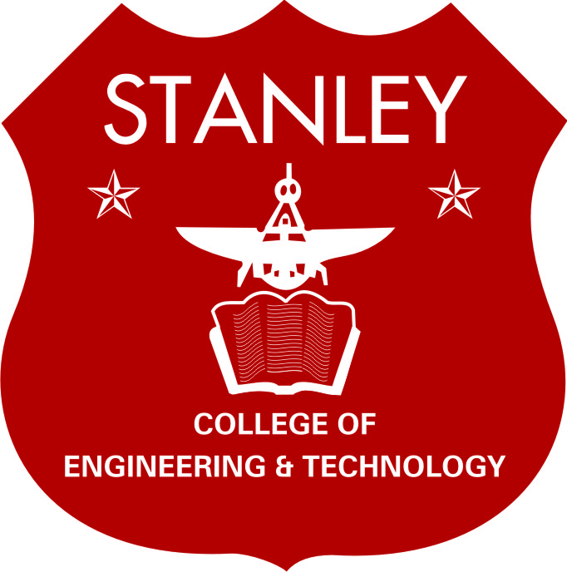
Stanley College of Engineering & Technology for Women
(Autonomous)

21st Governing Body Members

S.No | Name & Address | Category | Designation in Board
1 | Bishop M A Daniel,  Chairman, SCETW & Presiding Bishop,  Methodist Church in India | Management | Chairman
2 | Prof. S. Ramachandram,  Former Vice-Chancellor OU, Hyderabad and  Present Vice-Chancellor, Anurag University. | Eminent Educationist | Chief Advisor & Member
3 | Prof. P.Chandra Sekhar,  Principal, University College of Engineering .OU | State Government Nominee | Member
4 | Prof. B. Lavanya,  Dean, College Development Council, OU. | Affiliated University Nominee | Member
5 | Sri.K. Krishna Rao,  Correspondent, SCETW & | Management | Member
6 | Sri.R.Pradeep Reddy,  Chairman, Indur College of Engineering & Technology. & Director, SCETW. | Management | Member
7 | Mr. William R. Kumar,  Asst General Secretary,  Methodist Church in India. | Management | Member
8 | Sri. T. Rakesh Reddy,  Director, SCETW. | Management | Member
9 | Dr. A.Vinaya Babu,  Professor in CSE & Dean-Academics, SCETW. | Educationist | Member
10 | Dr. V.Anuradha,  Professor in English, & HOD, H&S Department,  SCETW. | Teacher of College | Member
11 | Dr. K.Vaidehi,  Professor & HOD, Dept of AI&DS & CME, SCETW. | Teacher of College | Member
12 | Mr. A. Ramesh,  Administrative Officer, SCETW. | Administrative Officer of College | Member
13 | Dr. Satya Prasad Lanka,  Principal, SCETW. | Principal | Member Secretary

Date: 06.07.2024 Principal & Member Secretary

